**Detailed system-process specifications for android**

Sequence diagram:

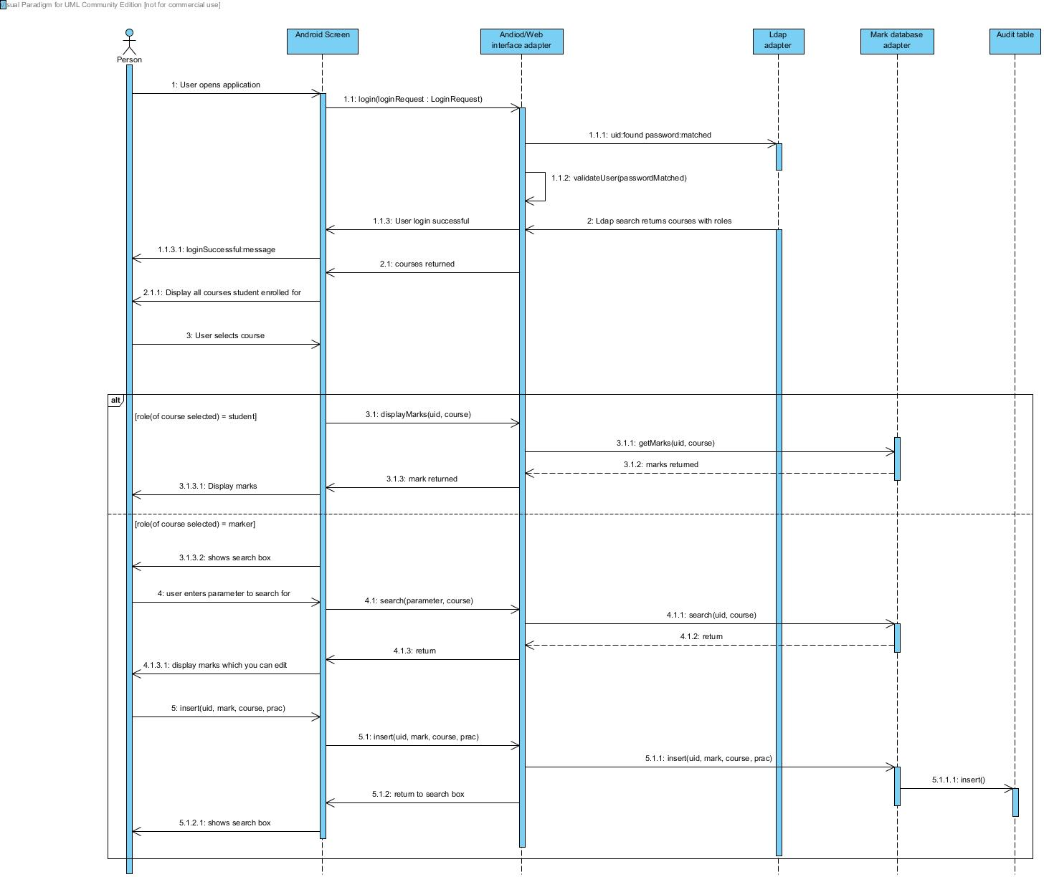

This sequence diagram covers the system-process specifications for android application. When the user opens the application the user will be prompted with a login screen. The user will login. The details he entered will be sent to interface(to let the android application and web interface connect an adapter/interface to improve flexibility, if for example ios application wants to be developed will be easier to integrate it with current system).

This interface will then communicate with ldap adapter to authenticate the user. Then personal details will be constructed displaying by course this will be provided by ldap since all that information is stored there.

For example(Appendices in master specification):

LDAP search for memberuid=u29052735 returns:

cn: stud COS333

cn: stud COS301

cn: stud COS326

cn: stud COS216

cn: stud COS330

User can select course that the user is enrolled for or marker or lecturer of. The sequence diagram alt is for when user is a student or when user is a marker. The reason for the course selector is since users can both be markers and students on different courses. If user is a marker his marks will be fetched by the mark database adapter and then will be sent to the interface and then will be displayed on android application.

If user is marker then search box will appear where marker can search students or names. He will only be able to search for students in his assigned practical groups. Then practical’s that are not currently locked that needs to be marked will be available for that student and marker can enter mark. Update must be made in audit-table when any mark is changed.

**UI screen designs and work-flow specifications:**

Activity diagram:

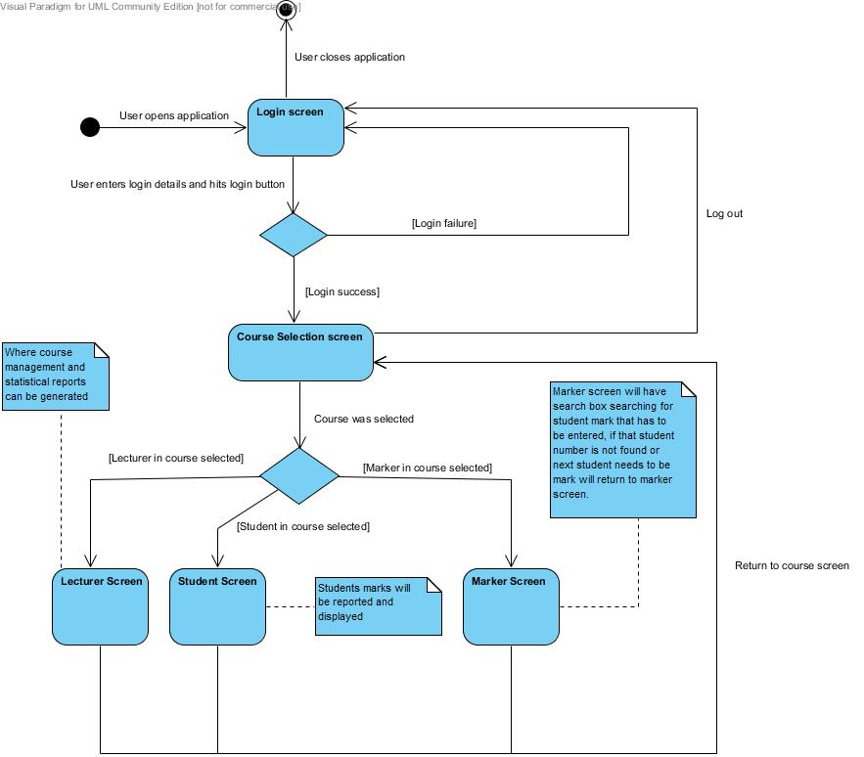

This is activity diagram of the flow of how the user interface of the android application should work. The rest of the android application layout will not be specified in detail like where the textboxes should be located since we want to keep the user interface flexible for implementation phase and don’t want to tie down and limit the implementation.